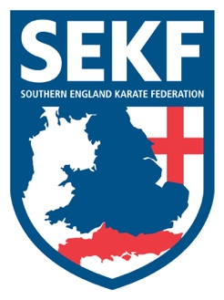
Newsletter May 2024

Dear parents and students,

Our Elite athletes enjoyed a lovely weekend at the Four Nations Karate Championships in Durham… Denis Margolin was on fire and won a great silver medal after four tough rounds. Great work!
Unfortunately, Chris Cytus was disqualified after knocking out his opponent and Emma Barnes lost out to the current England Champion but performed a good kata.
Carla Rudkin-Guillen helped coach as she was not able to compete after being withdrawn on medical grounds by her doctor.

Bank Holiday
Please note that due to the bank holiday there will be no classes running on Monday 6th May.

Saturday grading course for all students
There will be a special grading course on Saturday 11th May to be held at New Milton Health & Leisure Centre, (Gore Road, New Milton. BH25 6RR)
This course will be aimed at perfecting the new kata for your next belt (or tag)

White & Red belts: - 10.00am – 11.00am
Yellow and Orange tag: - 11.00am – 12.00pm
Orange belt to blue tag. - 12.00pm – 1.00pm
Blue belt and above. - 1.00pm - 2.00pm

Advanced Course
There will be an advanced course on Sunday 12th May for students’ blue belt and above plus squad members to be held at New Milton Health and Leisure Centre. (Gore road, BH25 6RR). This course will cover some exciting, advanced work including advanced Kata, knife defences and advanced kicks.

Time: 10.00am – 12.00pm Cost: £18.00
Please make payment to the SEKF – Account: 03807886 - Sort Code: 20-96-96

If you would like further private tuition in preparation for the next grading in July, please do not hesitate to organise a date/time with Sensei Danny.

Sensei Collin - 07966 303 585 Sensei Danny - 07813 329 710
collinrudkin@gmail.com www.sekf.co.uk

